**Practical No.05**

**Aim: Programs based on One-Dimensional Array**

**1. C Program to Find Largest element in Array.**

**Program:**

#include<stdio.h>

#include<conio.h>

void main()

{

int a[30], i, num, largest;

clrscr();

printf("\nEnter no of elements :");

scanf("%d", &num);

//Read n elements in an array

for (i = 0; i < num; i++)

scanf("%d", &a[i]);

//Consider first element as largest

largest = a[0];

for (i = 0; i < num; i++) {

if (a[i] > largest) {

largest = a[i];

}

}

// Print out the Result

printf("\nLargest Element : %d", largest);

getch();

}

**Output:**

Enter no of elements : 5

11 55 33 77 22

Largest Element : 77

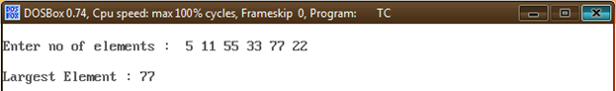

**2. C program to Reverse an Array**

**Program:**

#include<stdio.h>

#include<conio.h>

void main()

{

int n, c, d, a[100], b[100];

clrscr();

printf("Enter the number of elements in array\n");

scanf("%d", &n);

printf("Enter the array elements\n");

for (c = 0; c < n ; c++)

scanf("%d", &a[c]);

//Copying elements into array b starting from end of array a

for (c = n - 1, d = 0; c >= 0; c--, d++)

b[d] = a[c];

//Copying reversed array into original.

for (c = 0; c < n; c++)

a[c] = b[c];

printf("Reverse array is\n");

for (c = 0; c < n; c++)

printf("%d\n", a[c]);

getch();

}

**Output:**

Enter the number of elements in array

5

Enter the array elements

4

8

45

4568

1231

Reverse array is

1231

4568

45

8

4

